Access Goolge Calendar

Create a project in https://console.cloud.google.com/
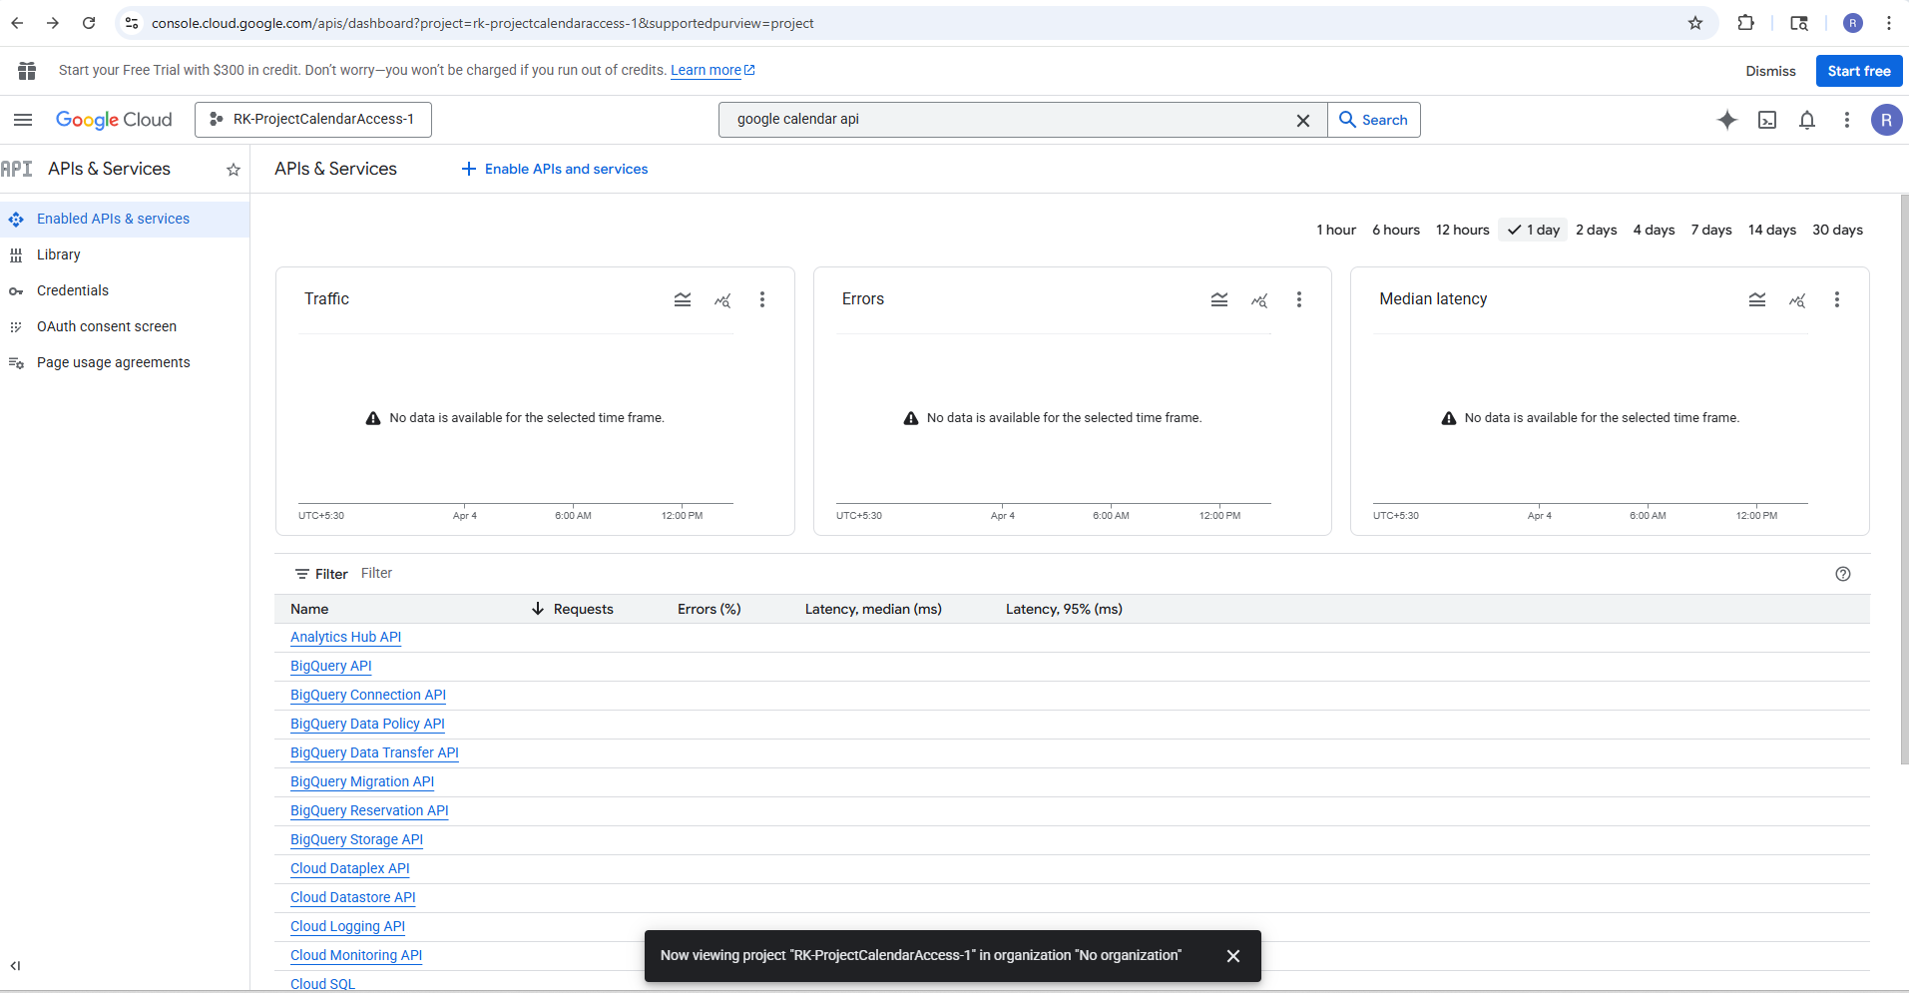
Search for Google Calendar API & enable it
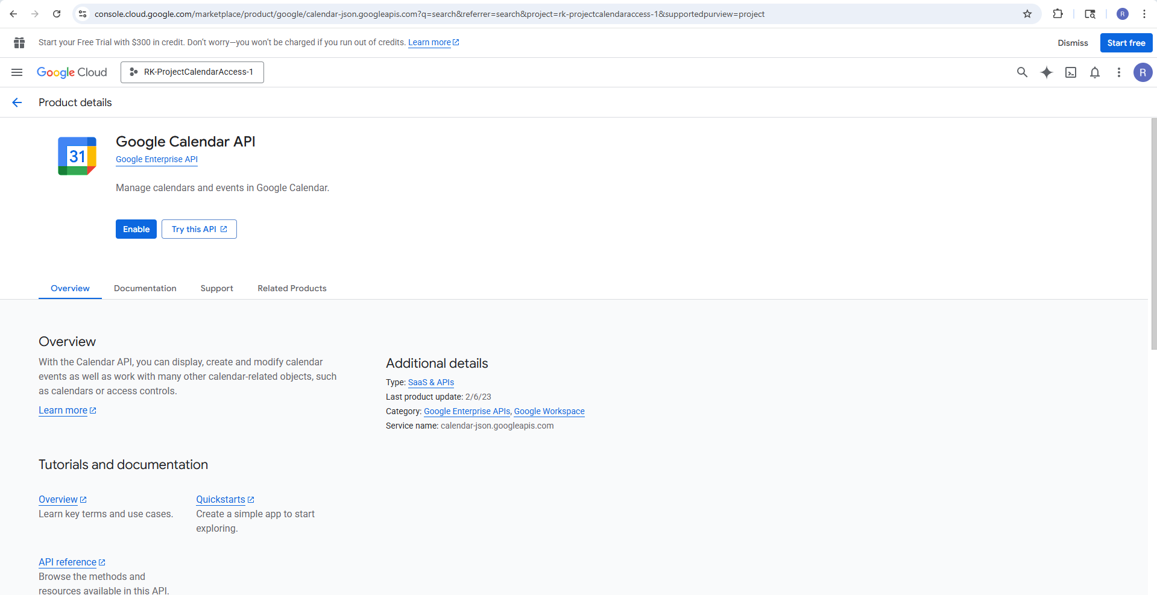
Go Auth Consent Screen on left pane.
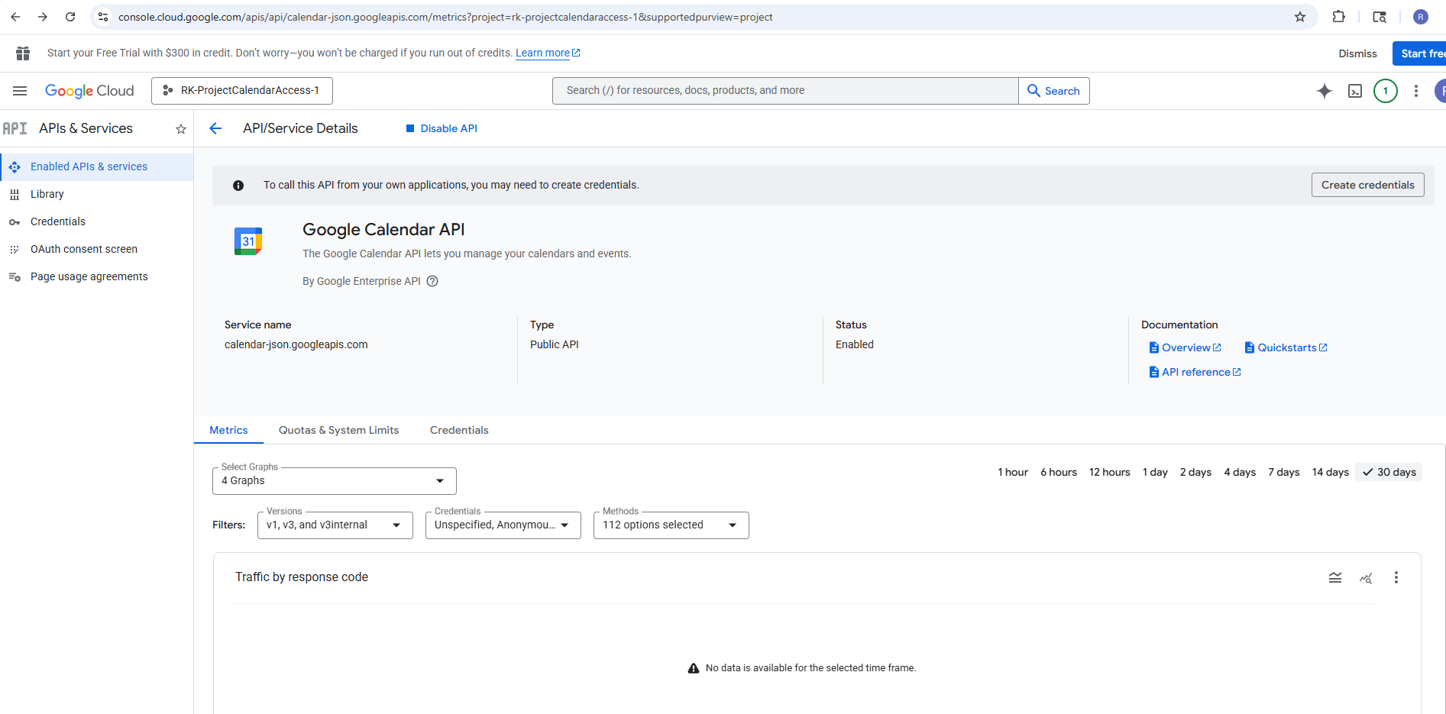
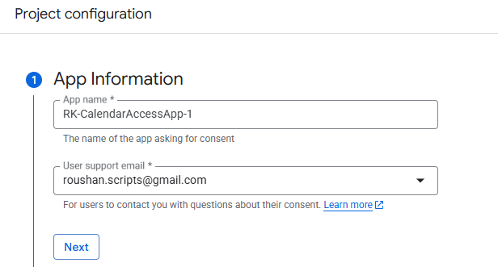
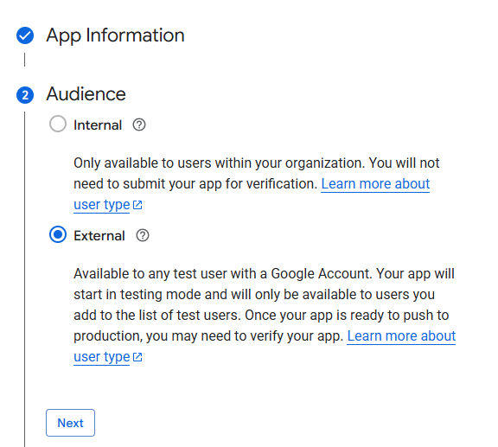
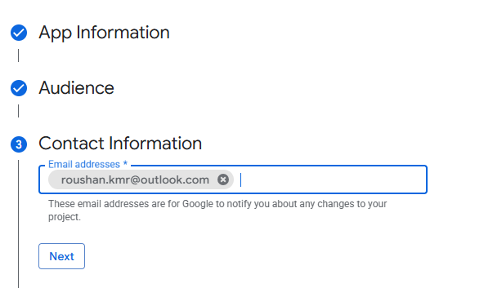
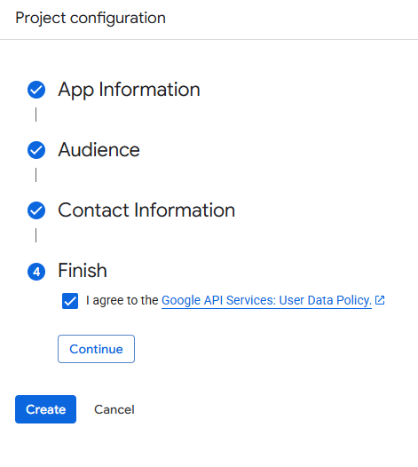
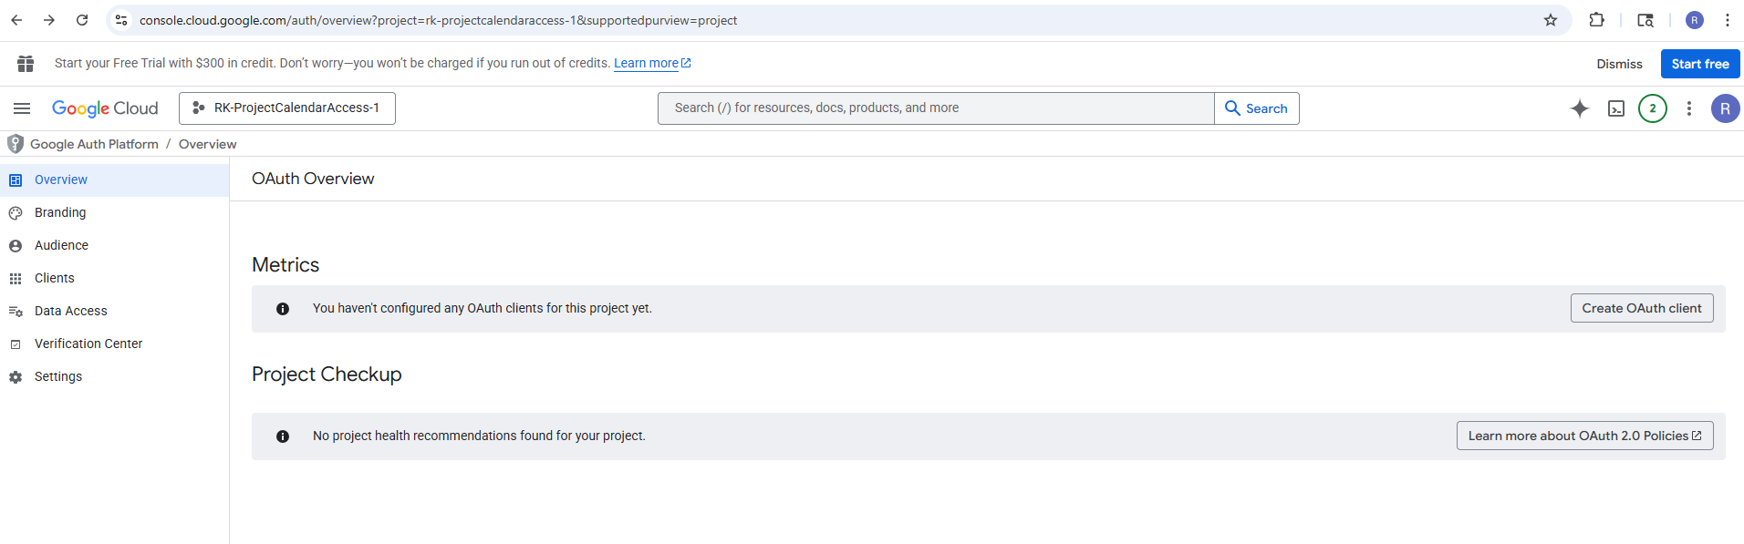
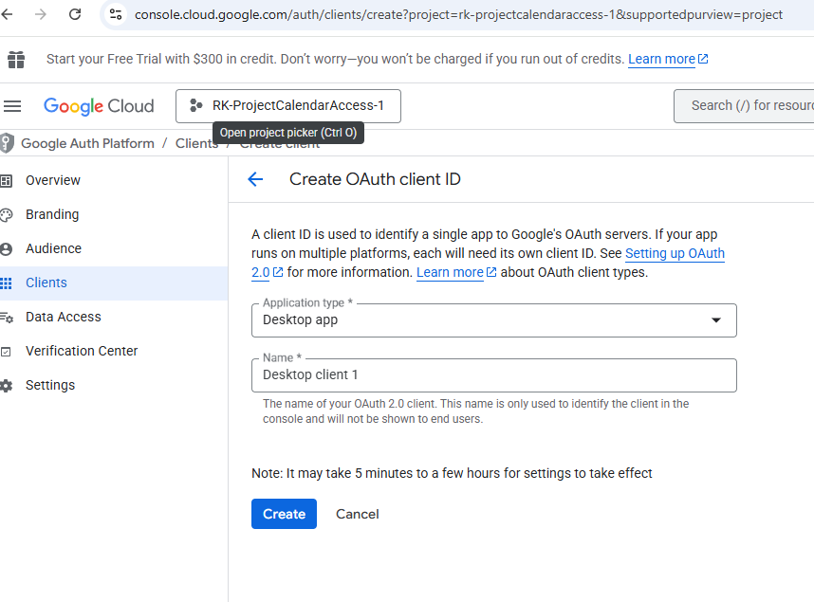
Client ID:
441728545318-8m376uvqemeqd0h6u2gkesh6s18dhige.apps.googleusercontent.com

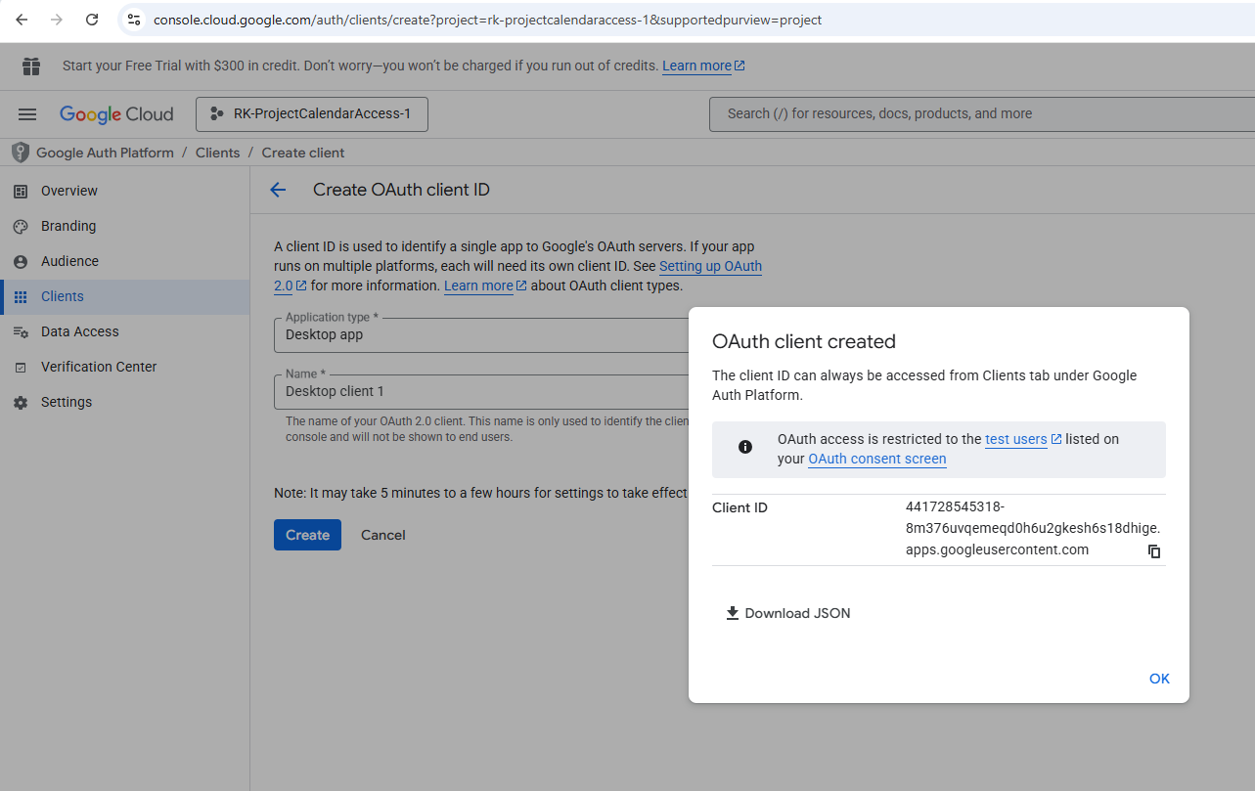
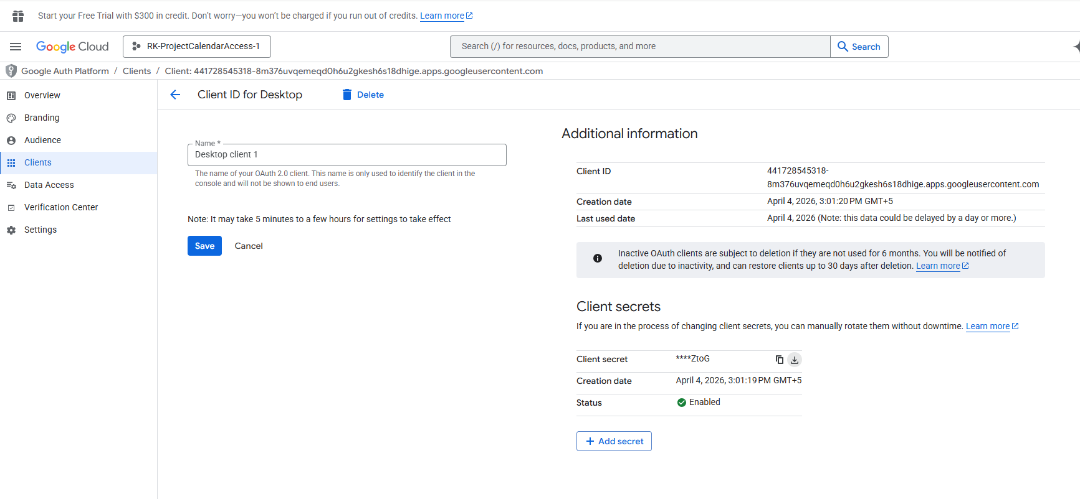

Library to install:
pip install --upgrade google-api-python-client google-auth-httplib2 google-auth-oauthlib
pip install google-auth google-auth-oauthlib google-api-python-client

Create a folder like
$ mkdir GetMyGoogleCalendarV0.2
$ cd GetMyGoogleCalendarV0.2
$ python3 -m venv venv
$ source venv/bin/activate
$ python3 -m pip install google-auth google-auth-oauthlib google-api-python-client
# Copy following files to the current folder
credentials.json
getMyCalendarData.py
runShowMyGoogleCalendar.service
sendMessageToEsp32.py
# run senMessageToEsp32.py
$python sendMessageToEsp32.py
# It will print some link on the command line, click on it and login it with google account ‘roushan.scripts@gmail.com’
# grant access to calendar data on below page, click on continue.

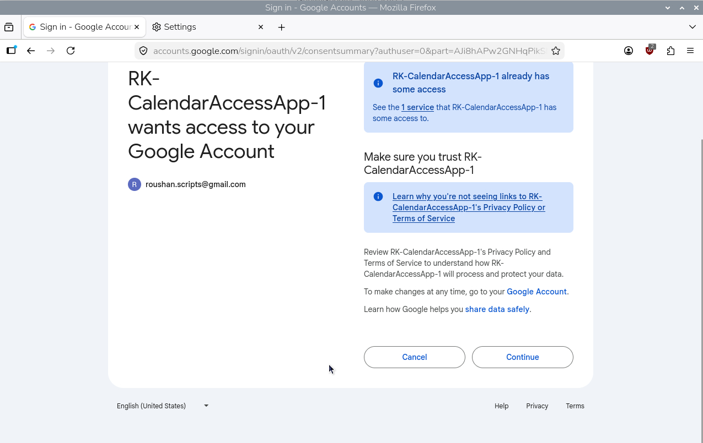

# content of file ‘runShowMyGoogleCalendar.service’

[Unit]
Description=My Custom Bash Script Service
After=network.target
[Service]
User=pi
Goup=pi
WorkingDirectory=/home/pi/GetMyGoogleCalendarV0.2/
# Point directly to the python executable inside the virtual environment/home/pi/GetMyGoogleCalendarV0.2/venv/bin/python3 /home/pi/GetMyGoogleCalendarV0.2//sendMessageToEsp32.py
ExecStart= /home/pi/GetMyGoogleCalendarV0.2/venv/bin/python3 /home/pi/GetMyGoogleCalendarV0.2/sendMessageToEsp32.py
Restart=always
# Give it a few seconds before retrying so it doesn't trigger the "too quickly" error
RestartSec=5
# Using journal makes debugging much easier later
StandardOutput=journal
StandardError=journal
[Install]

[Unit]
Description=Google Calendar to ESP32 Script
After=network.target
[Service]
Type=simple
User=pi
WorkingDirectory=/home/pi/GetMyGoogleCalendarV0.2
ExecStart=/home/pi/GetMyGoogleCalendarV0.2/venv/bin/python /home/pi/GetMyGoogleCalendarV0.2/sendMessageToEsp32.py
Restart=on-failure
RestartSec=5
[Install]
WantedBy=multi-user.target

Paste above content to below file
$ sudo nano /etc/systemd/system/runShowMyGoogleCalendar.service
pi@RK-Pi3:~ $ sudo systemctl daemon-reload
pi@RK-Pi3:~ $ sudo systemctl enable runShowMyGoogleCalendar.service
Created symlink '/etc/systemd/system/multi-user.target.wants/runShowMyGoogleCalendar.service' → '/etc/systemd/system/runShowMyGoogleCalendar.service'.
pi@RK-Pi3:~ $ sudo systemctl start runShowMyGoogleCalendar.service
pi@RK-Pi3:~ $ sudo systemctl status runShowMyGoogleCalendar.service
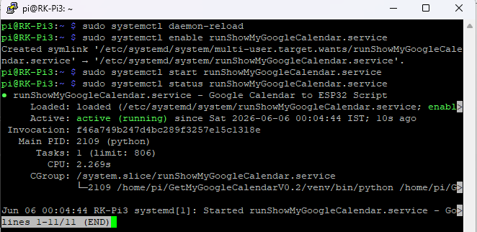

sudo journalctl -u runShowMyGoogleCalendar.service -f

